- When in doubt, tell the truth.

- It is curious that physical courage should be so common in the world, and moral courage so rare.

- It is better to keep your mouth shut and appear stupid than to open it and remove all doubt.
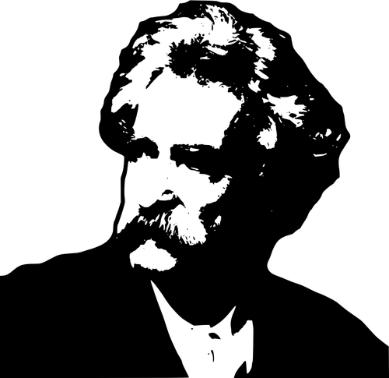

- All generalizations are false, including this one.

- Always do right. This will gratify some and astonish the rest.

- The only way to keep your health is to eat what you don’t want, drink what you don’t like, and do what you’d rather not.

