Group Name _____________________________ Period _____ Date ____________
Group Members Participating : ___________________________________________ ____________________________________________________________________

Setting Assignment
Literature Reading Circles

- Visually recreate the main setting of your book. Choose one of the following:
Be sure your setting includes labels, details, and the title of your book at the top.

  - Draw a Map of the setting in your book which includes the main places where significant events have happened in your book so far. OR…

  - Draw a Journey that your main character has taken along the way.

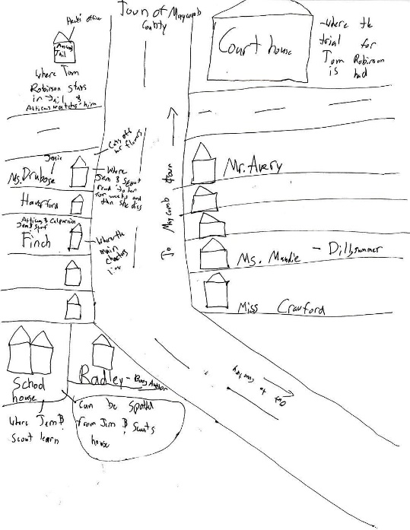

- How does setting affect your character s actions, choices, thoughts, or personality?

On the back of this paper, write a well-developed paragraph that makes a claim and is supported with evidence and analysis.
EXAMPLE CLAIM: “The setting of the Dursleys home in Harry Potter created an environment for Harry to be humble.”

________________________________________________________________________________________________________________________________________
____________________________________________________________________
________________________________________________________________________________________________________________________________________
____________________________________________________________________
________________________________________________________________________________________________________________________________________
____________________________________________________________________
________________________________________________________________________________________________________________________________________
____________________________________________________________________
________________________________________________________________________________________________________________________________________
____________________________________________________________________
________________________________________________________________________________________________________________________________________
____________________________________________________________________
________________________________________________________________________________________________________________________________________
____________________________________________________________________
________________________________________________________________________________________________________________________________________

